IICS

SCD1

SELECTING THE SOURCE

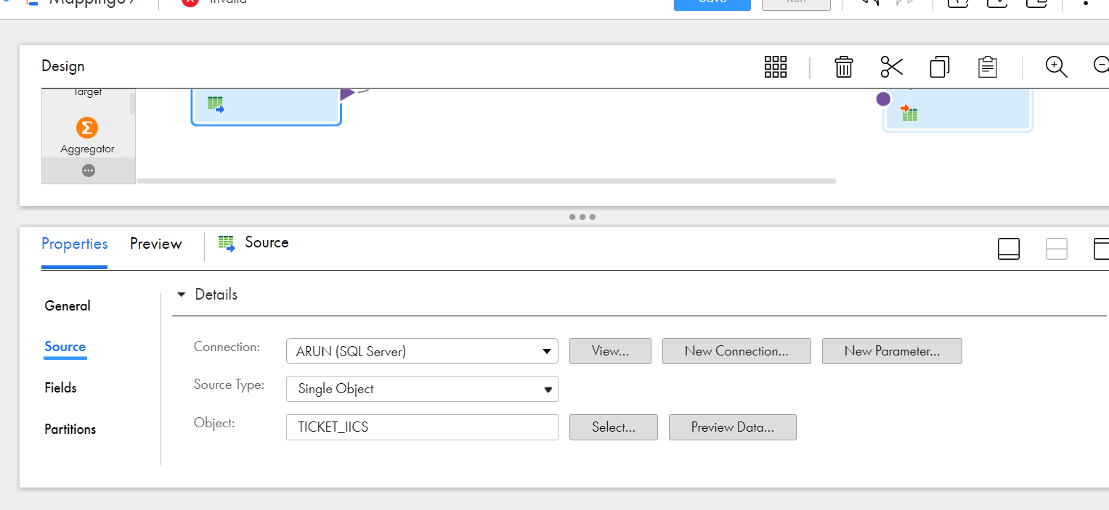

ADDING ALL THE INPUT COLUMNS AS OUTPUT COLUMNS TO PERFORM THE CHECKSUM OPERATION

PERFORMING THE CHECKSUM OPERATION USING MD5 METHOD

NEXT STEP WE NEED TO SELECT THE LOOK UP OBJECT AND VALIDATE THE LOOKUP CONDTION

PERFORMING EXPRESSION TASK TO INSERT AND UPDATE FUNCTION

ROUTER OPERATION TO GET THE INSERT AND UPDATE OUTPUTS

INSERT EXPRESSION TASK

UPDATE EXPRESSION TASK

SELECTING TWO TARGETS AND PERFORMING THE FIELD MAPPING AND UPDATING THE COLUMN WHICH NEEDS TO BE UPDATED

AFTER VALID MAPPING WE ARE RUNNING THE TASK

RESULTS AFTER SUCCEFULL RUN IN DB

THE DATA IS INSERTED

NOW UPDATING THE ROW AND CHECHKING THE MAPPING

SOURCE IS UPDATED

SINCE WE HAVE UPDATED ONLY ONE ROW IT PASSES THE UPDATE ROW ALONE

UPDATED RESULT

SCD2 IN IICS

SELECTING THE SOURCE

ADDING ALL THE INPUT COLUMNS AS OUTPUT COLUMNS TO PERFORM THE CHECKSUM OPERATION

FLAGGING OPERATION

ADDING ROUTER TO 3 OUTPUT FIELDS INSERT,INSCLS,UPDATE

EXPRESSION 1 INSERT

EXPRESSION 2 INSERT CLOSE

EXPRESSION 3

FIELD MAPPING OF ALL 3 TARGETS

RUNNING THE TASK AFTER VALIDATION

DESTINATION RESULT

UPDATING THE ROW AND CHECHKING THE UPDATION TASK

2 ROWS ARE UPDATED AND TASK IS SUCCESSFUL IT IS LOADED IS DB ALSO

2 ROWS ARE UPDATED AND TASK IS SUCCESSFUL IT IS LOADED IS DB ALSO

AGGREGRATE TRANSFORMATION

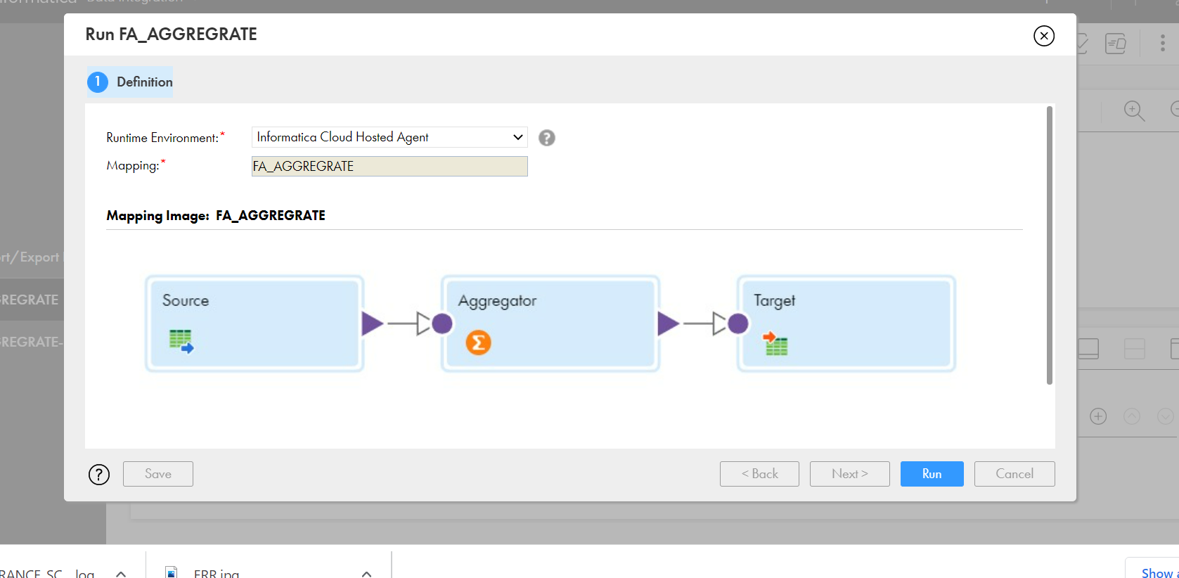

MAPPING OG AGGREGRATE TASK

SUM BY AGGREGRATE

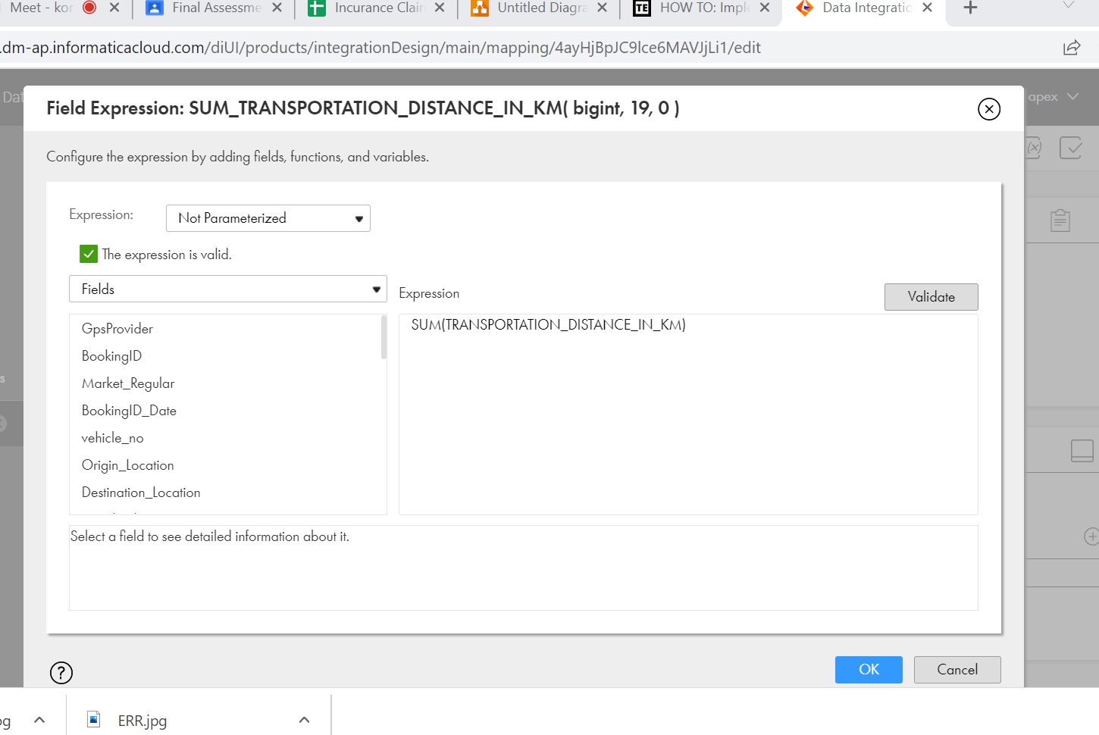

AVG AGGREGRATE

COUNT BY AGGREGRATE

MIN AGGREGRATE

MAX AGGREGRATE

GROUP BY

SUCCESS RESULTS OF AGGRGRATE

SOURCE TO DESTINATION TRANSFORMATION

TRANSFORMATION FUNCTION USING RANKING

MAPPING OF RANKING

SUCCESS RESULT OF RANK TRANSFORMATION

REPLICATION TASK

THIS TASK IS TO REPLICATE SAME TABLE TO OTHER

SELECTING THE OBJECT TO REPLICATE

SELECT THE COLUMNS AND OTHER FILTER DETAILS

RUNNING THE TASK

SUCCESS OF THE TASK

REPLICATION WHOLE DB

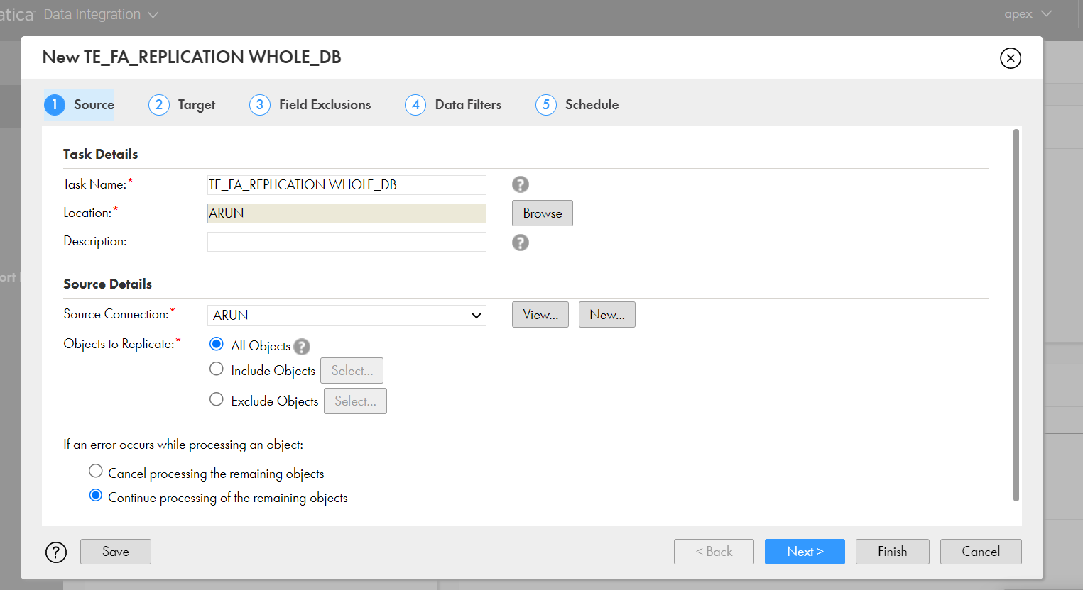

TARGET FIELD

SUCCESS TASK

ROWS PASSING

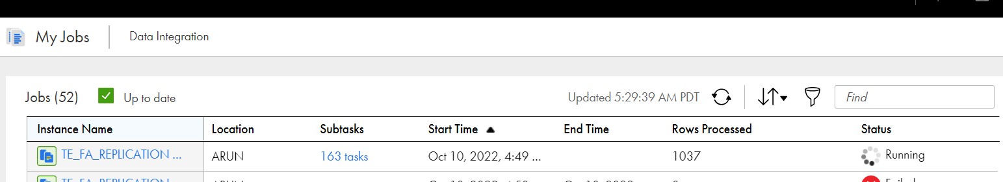

ALL the rows are transfered

